RETAIL INVENTORY ANALYTICS USING GOOGLE COLAB

Submitted By :-
Name: Vedant Wadekar
Course: B.Tech IT
Submitted To : Latthe Mam.
Academic Year: 2025-26

1. Introduction
Retail inventory management plays a vital role in ensuring product availability and maintaining business profitability. This project analyzes retail inventory data using Python and Google Colab to identify sales trends, stock levels, supplier contributions, and inventory performance.
The analysis helps management make informed decisions regarding stock replenishment, supplier management, and inventory optimization.

2. Objectives
The objectives of this project are:
- Identify product categories generating the highest sales.
- Detect products approaching reorder levels.
- Analyze stock availability and sales performance.
- Evaluate supplier contribution to inventory.
- Generate business insights for inventory management.

3. Tools and Technologies Used
- Google Colab
- Python
- Pandas
- NumPy
- Matplotlib
- Seaborn
- Microsoft Excel

4. Dataset Overview
The Retail Inventory dataset contains information about products, categories, suppliers, stock levels, sales, and reorder points.
Dataset Summary:
- Total Records: 1000
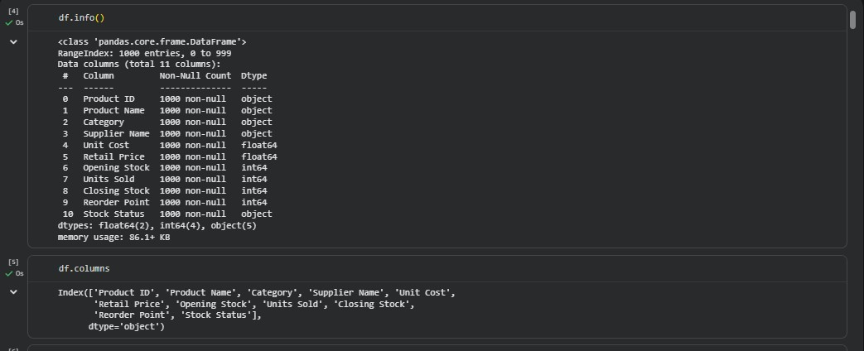
- Total Columns: 11
- Missing Values: 0
- Duplicate Records: 0
Attributes:
- Product ID
- Product Name
- Category
- Supplier Name55
- Unit Cost22below
- Retail Price
- Opening Stock
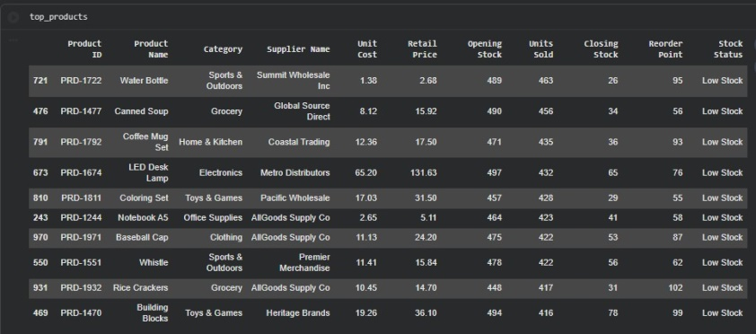
- Units Sold
- Closing Stock
- Reorder Point
- Stock Status

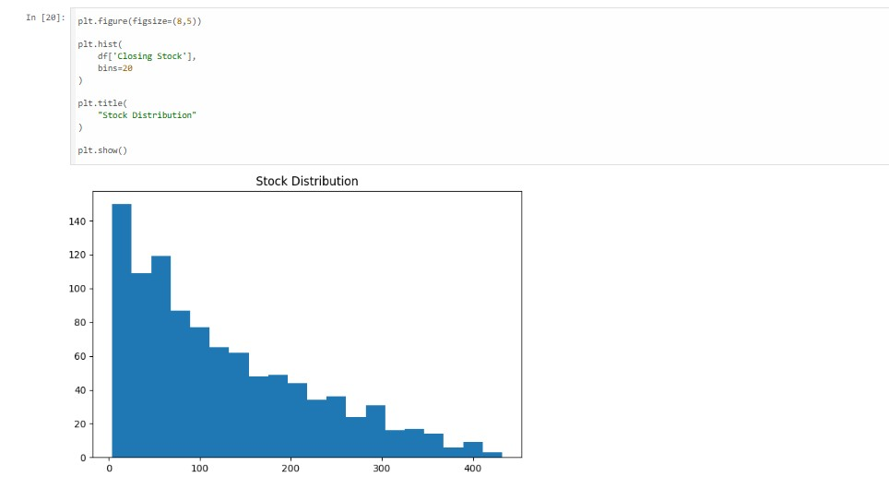
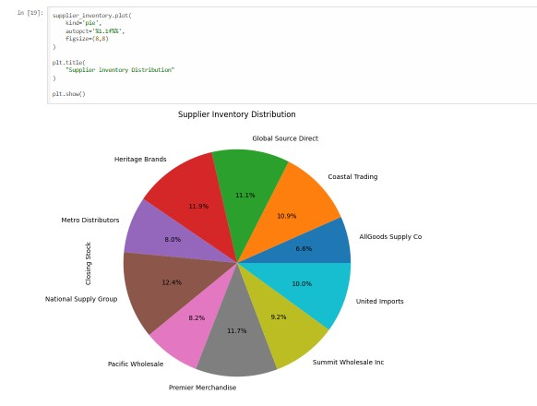
1

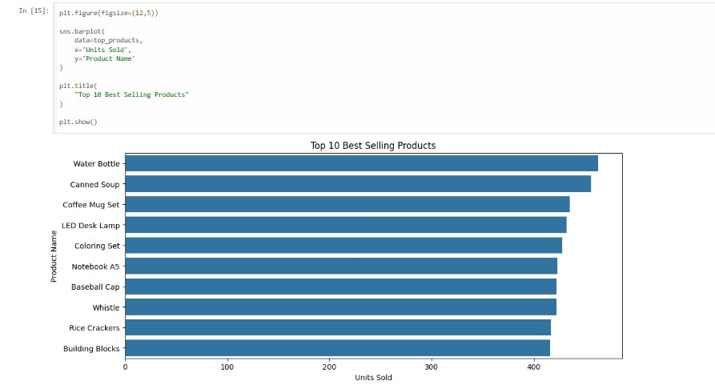

5. Data Cleaning
The following preprocessing steps were performed:
- Checked for missing values.
- Verified data types.
- Checked for duplicate records.
- Validated stock-related fields.
Results:
- No missing values found.
- No duplicate records found.
- Dataset was clean and ready for analysis.

6. Exploratory Data Analysis

6.1 Category-wise Product Count
(Insert Bar Chart Screenshot)
This analysis shows the number of products available in each category. Beauty and Sports & Outdoors categories contained the highest number of products.

6.2 Category-wise Units Sold
(Insert Chart Screenshot)
This analysis identifies which categories contribute the highest sales volume.

6.3 Top 10 Best-Selling Products
(Insert Chart Screenshot)
This analysis highlights the products with the highest sales performance.

6.4 Top 10 Low-Stock Products
(Insert Chart Screenshot)
This analysis identifies products that may require immediate replenishment.

6.5 Supplier-wise Inventory Distribution
(Insert Pie Chart Screenshot)
This analysis shows how inventory is distributed among suppliers.

7. Data Visualizations
The following visualizations were created:
- Category-wise Product Count (Bar Chart)
- Category-wise Units Sold (Bar Chart)
- Top 10 Best-Selling Products (Bar Chart)
- Top 10 Low-Stock Products (Bar Chart)
- Supplier-wise Inventory Distribution (Pie Chart)
- Stock Distribution (Histogram)
- Correlation Heatmap (Bonus)

8. Business Insights
- Products with stock below reorder point require immediate replenishment.
- High-selling categories contribute significantly to overall sales performance.
- Some products have lower sales despite adequate stock levels, indicating slow-moving inventory.
- Best-selling products should receive priority during inventory planning.
- Excessive dependence on a single supplier may create supply chain risks.

9. Recommendations
- Maintain safety stock for fast-moving products.
- Monitor low-stock products regularly.
- Improve demand forecasting using historical sales data.
- Diversify suppliers to reduce dependency risks.
- Use data-driven inventory planning for better stock management.

10. Conclusion
The Retail Inventory Analytics project successfully analyzed inventory data and generated meaningful business insights. Through data cleaning, exploratory analysis, and visualization, important trends related to sales performance, inventory levels, and supplier contribution were identified. The findings can help improve inventory control, reduce stock shortages, and support better business decision-making.

11. References
- Google Colab Documentation – https://colab.research.google.com
- Pandas Documentation – https://pandas.pydata.org/docs/
- NumPy Documentation – https://numpy.org/doc/
- Matplotlib Documentation – https://matplotlib.org/stable/users/index.html
- Seaborn Documentation – https://seaborn.pydata.org/
- Microsoft Excel Documentation – https://support.microsoft.com/excel
- Retail Inventory Dataset provided for academic project work.

